



**Assignments**

**Software Documentation and**

**Technical Writing**

| *Name* | *ID* |
| --- | --- |
| Amjad Alfalahi | 444000591 |
| Layla Alshiki | 444002579 |

**Application name:**

**HungerStation**

A special application for delivering orders from restaurants, pharmacies, food markets, and more..

**Requirements:**

1. The system must be user-friendly for both users and delivery personnel.

2. The application should offer multiple and diverse options such as restaurants, cafes, grocery stores, and pharmacies.

3. The application must provide multiple payment methods.

4. The application should have a system for tracking and monitoring the order status by the user.

5. A rating system and the ability to add comments to ensure service quality.

6. Users should be able to communicate with the delivery personnel in a structured way.

**We asked these questions to a number of people :**

1. Do you use delivery apps?

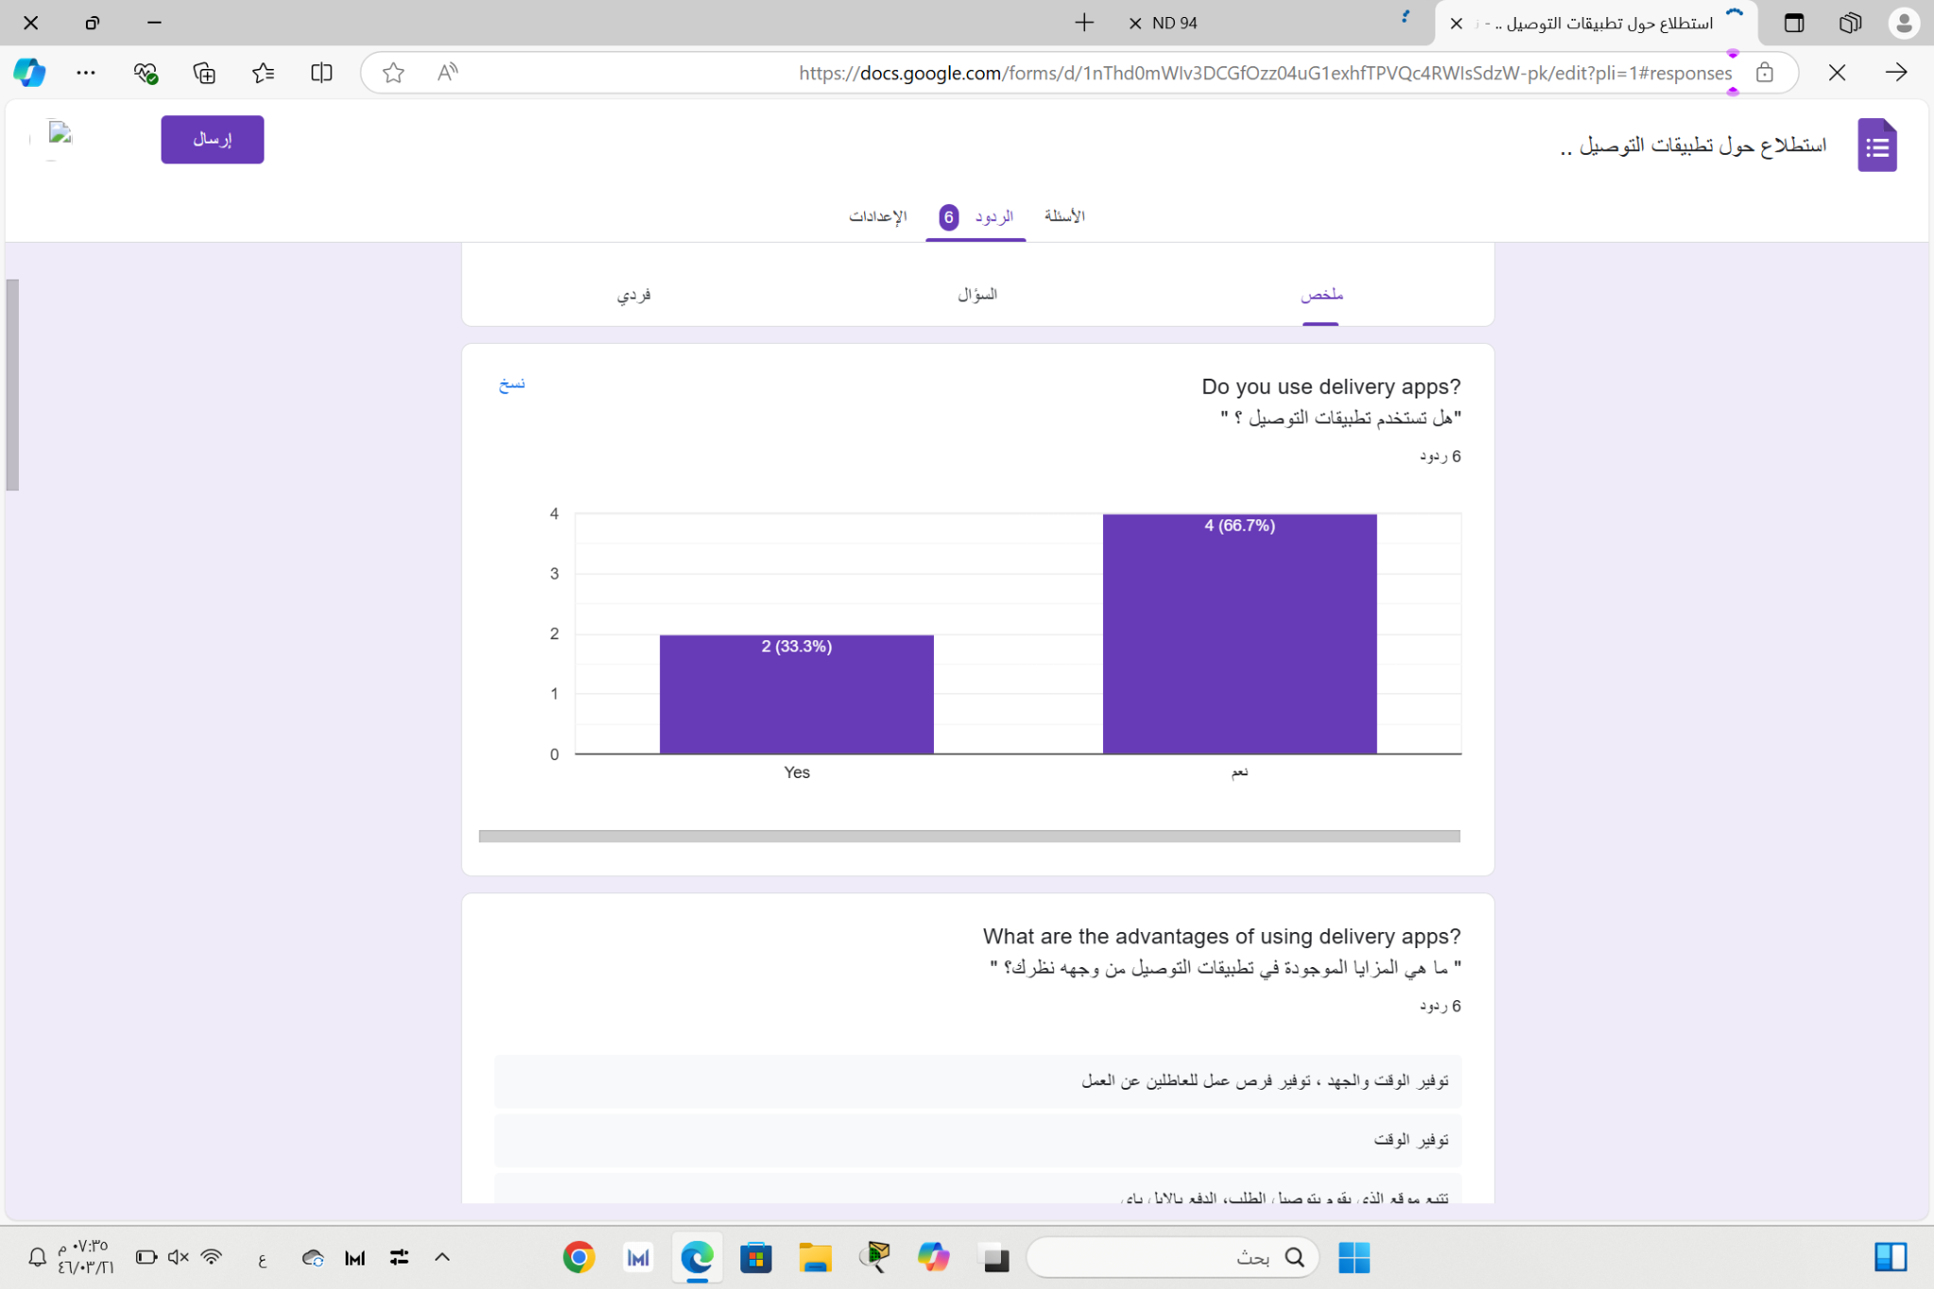

2. What are the advantages of using delivery apps?

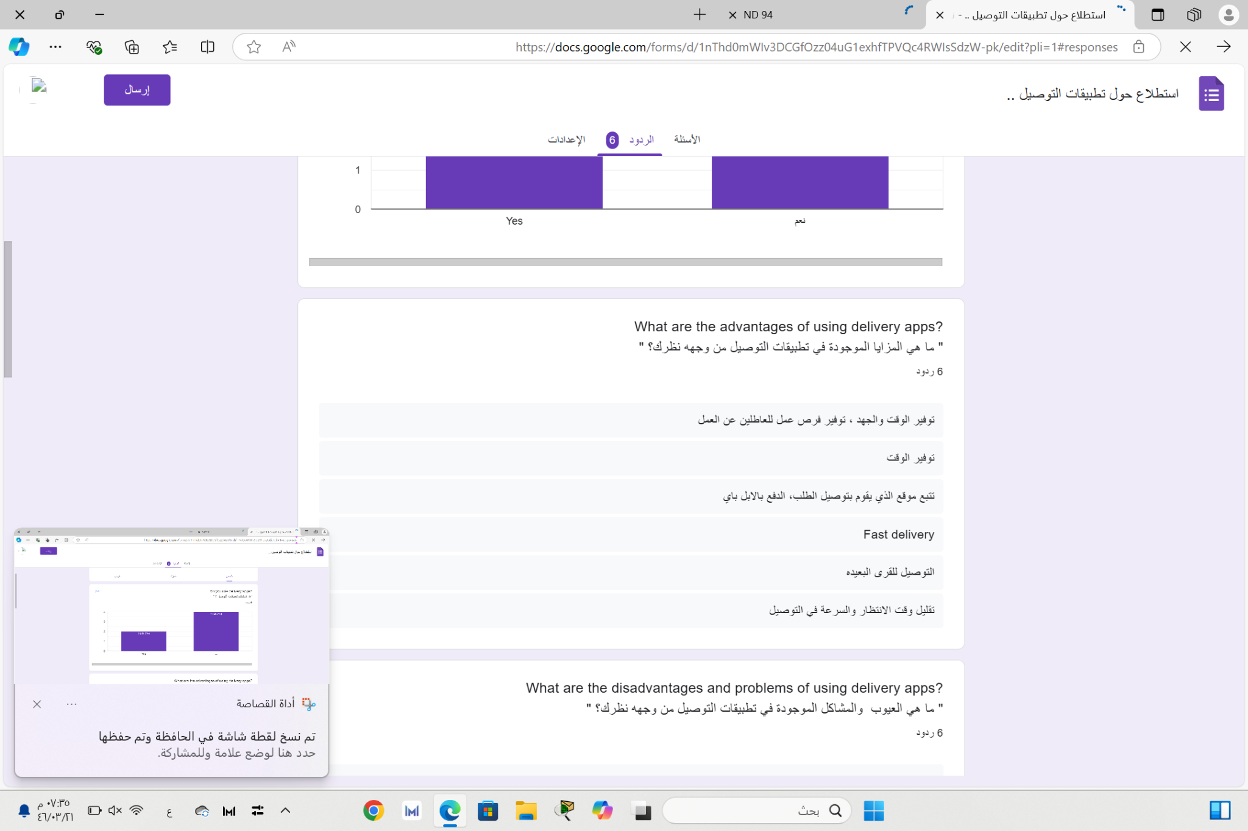

3. In your opinion, what is the appropriate duration for an

order to arrive?

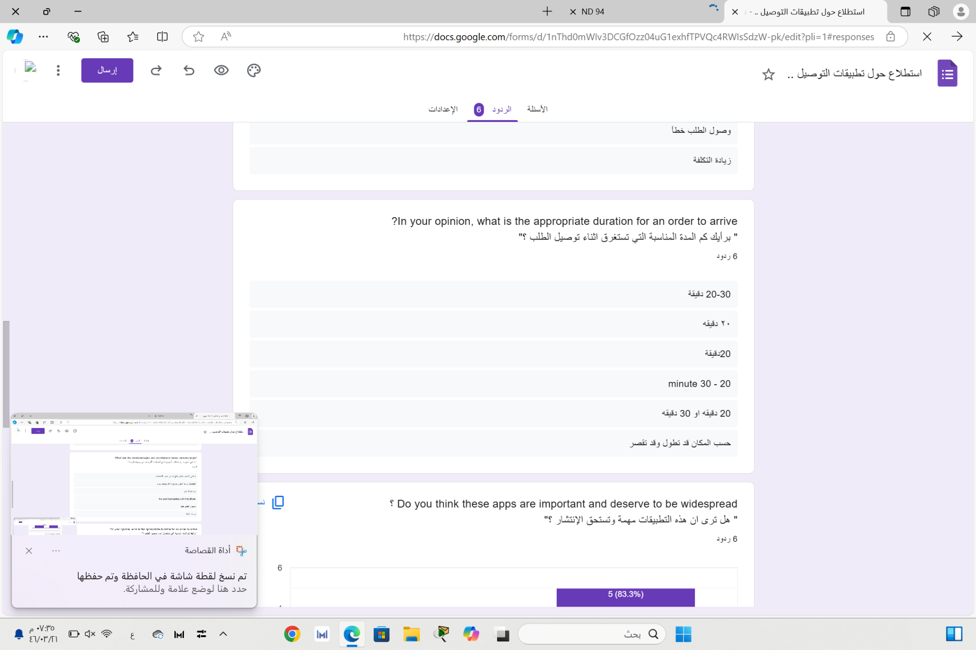

4. Do you think these apps are important and deserve to be widespread?

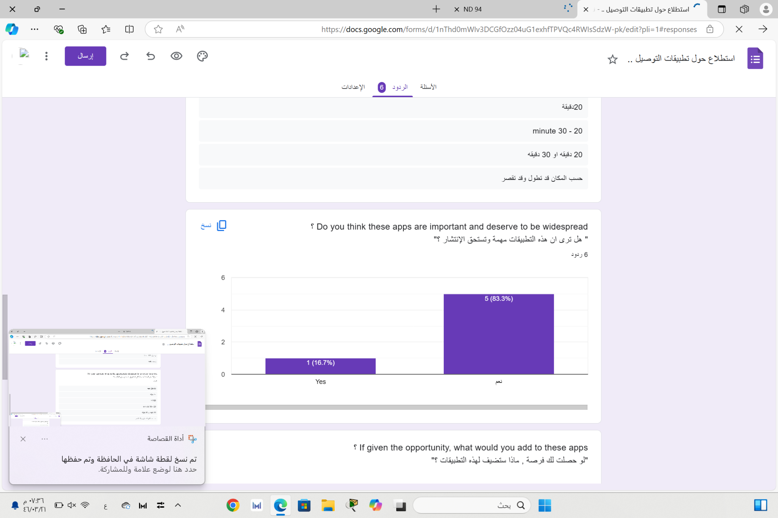

5. If given the opportunity, what would you add to these apps?

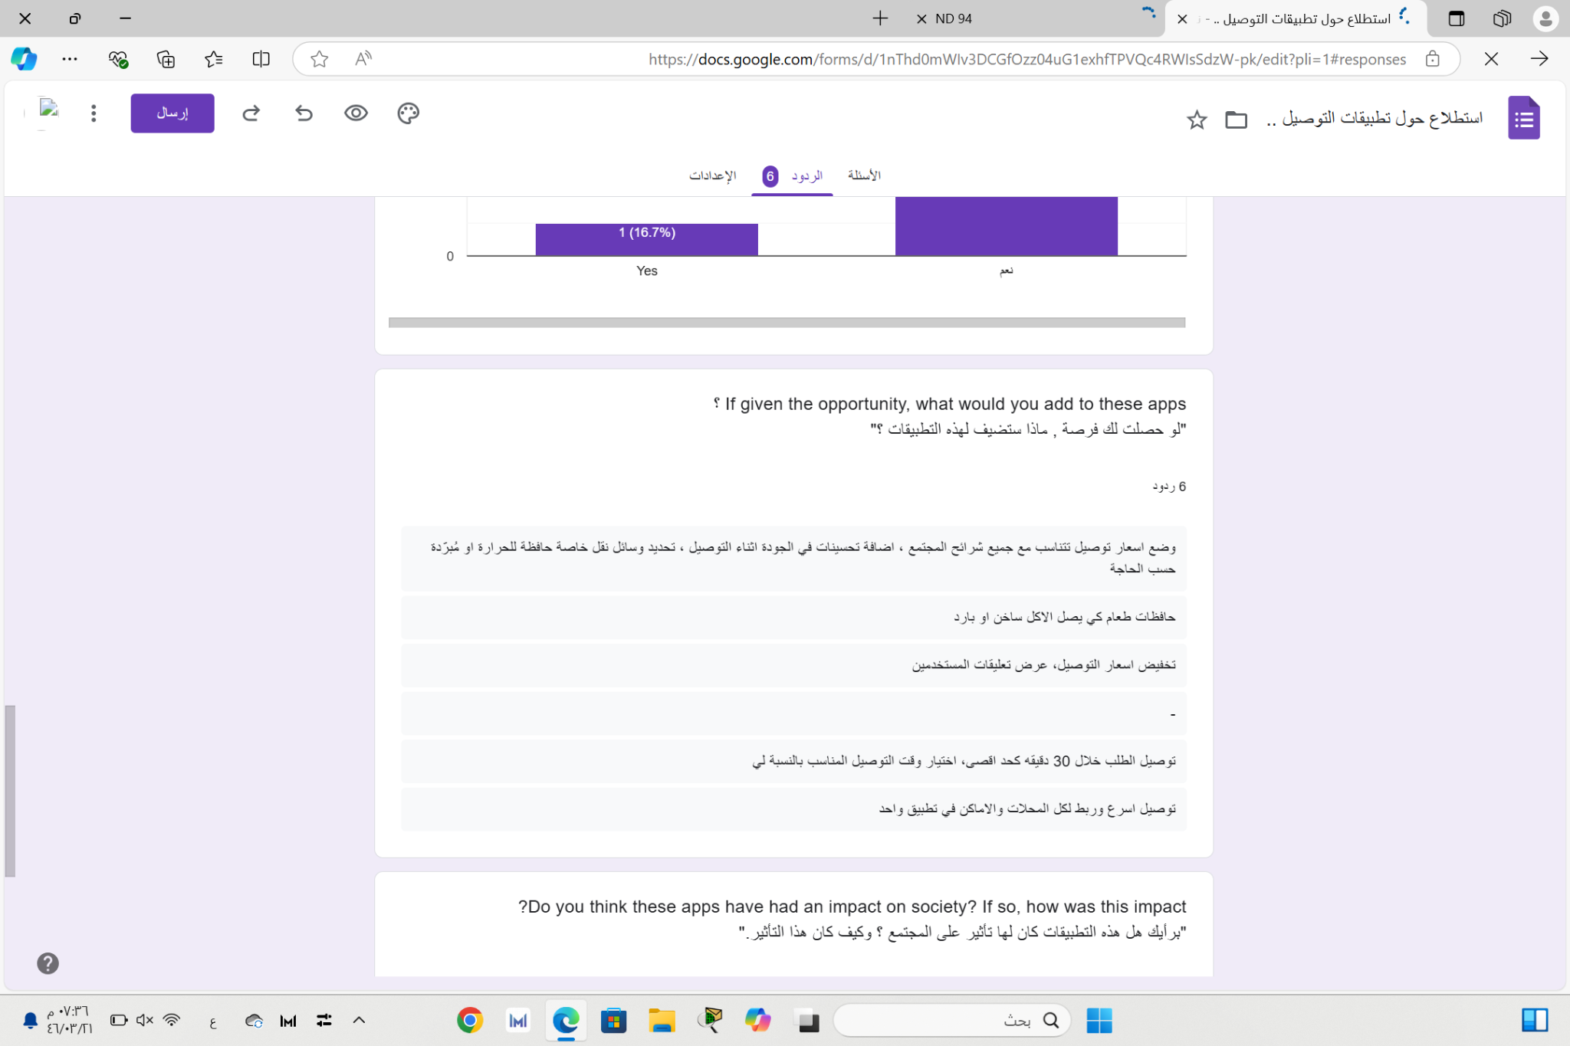

6. Do you think these apps have had an impact on society?

If so, how was this impact?

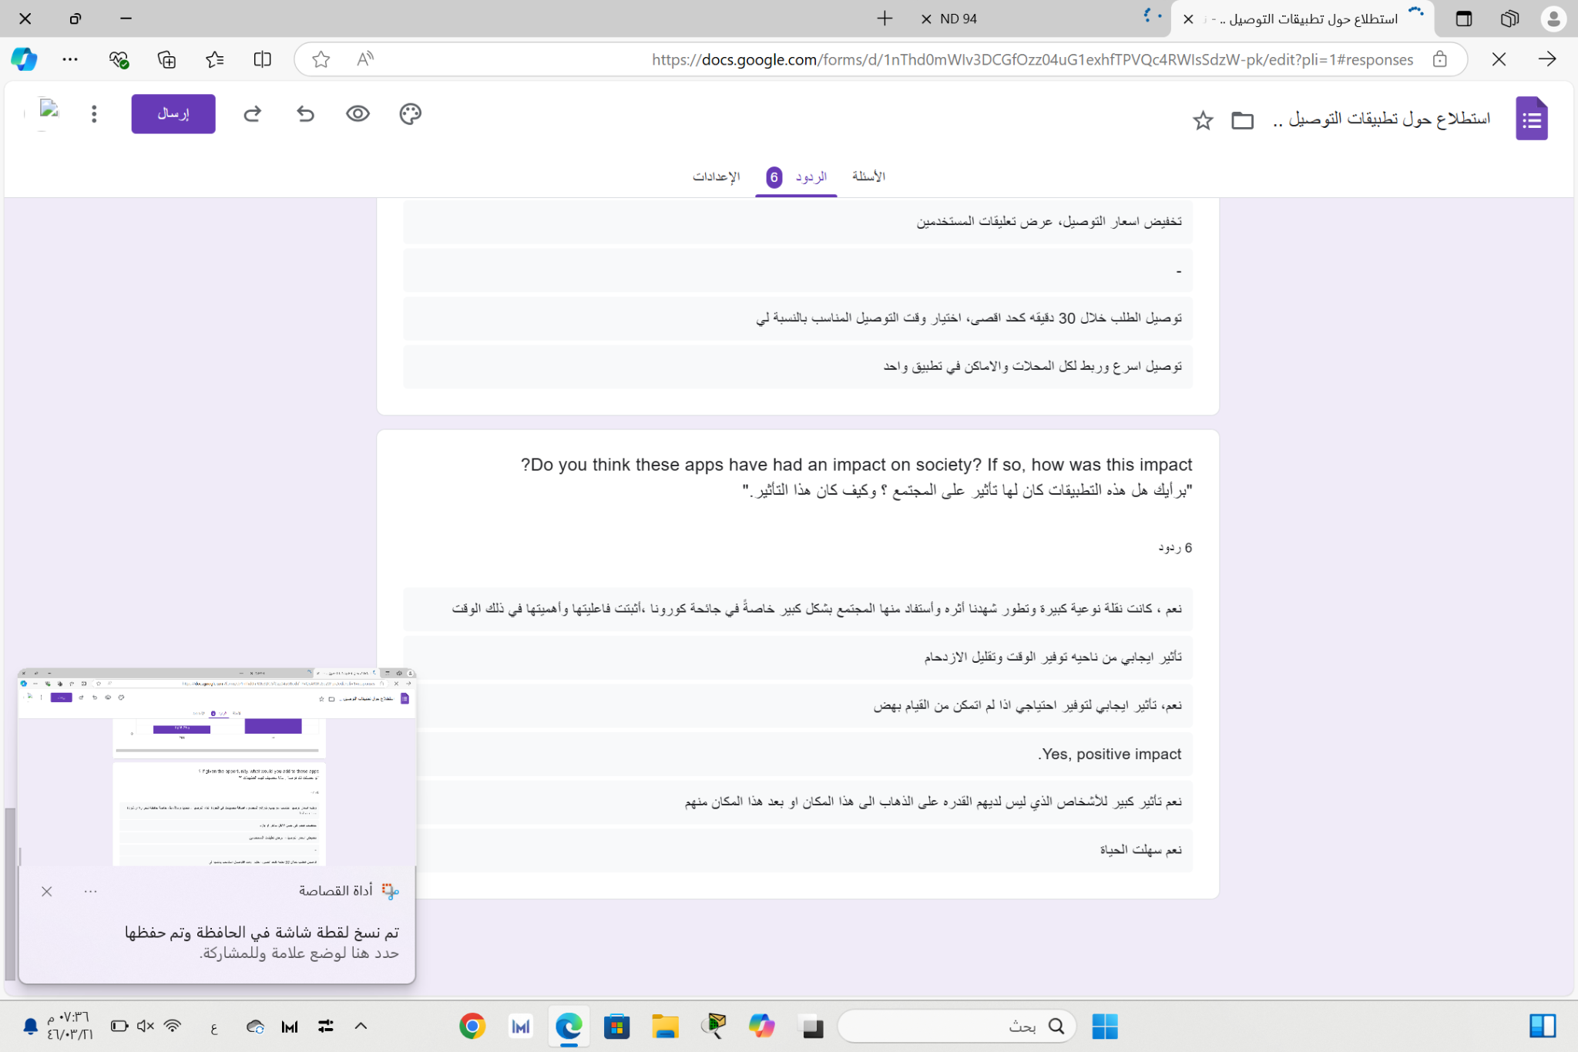

7. What are the disadvantages and problems of using delivery

apps ?

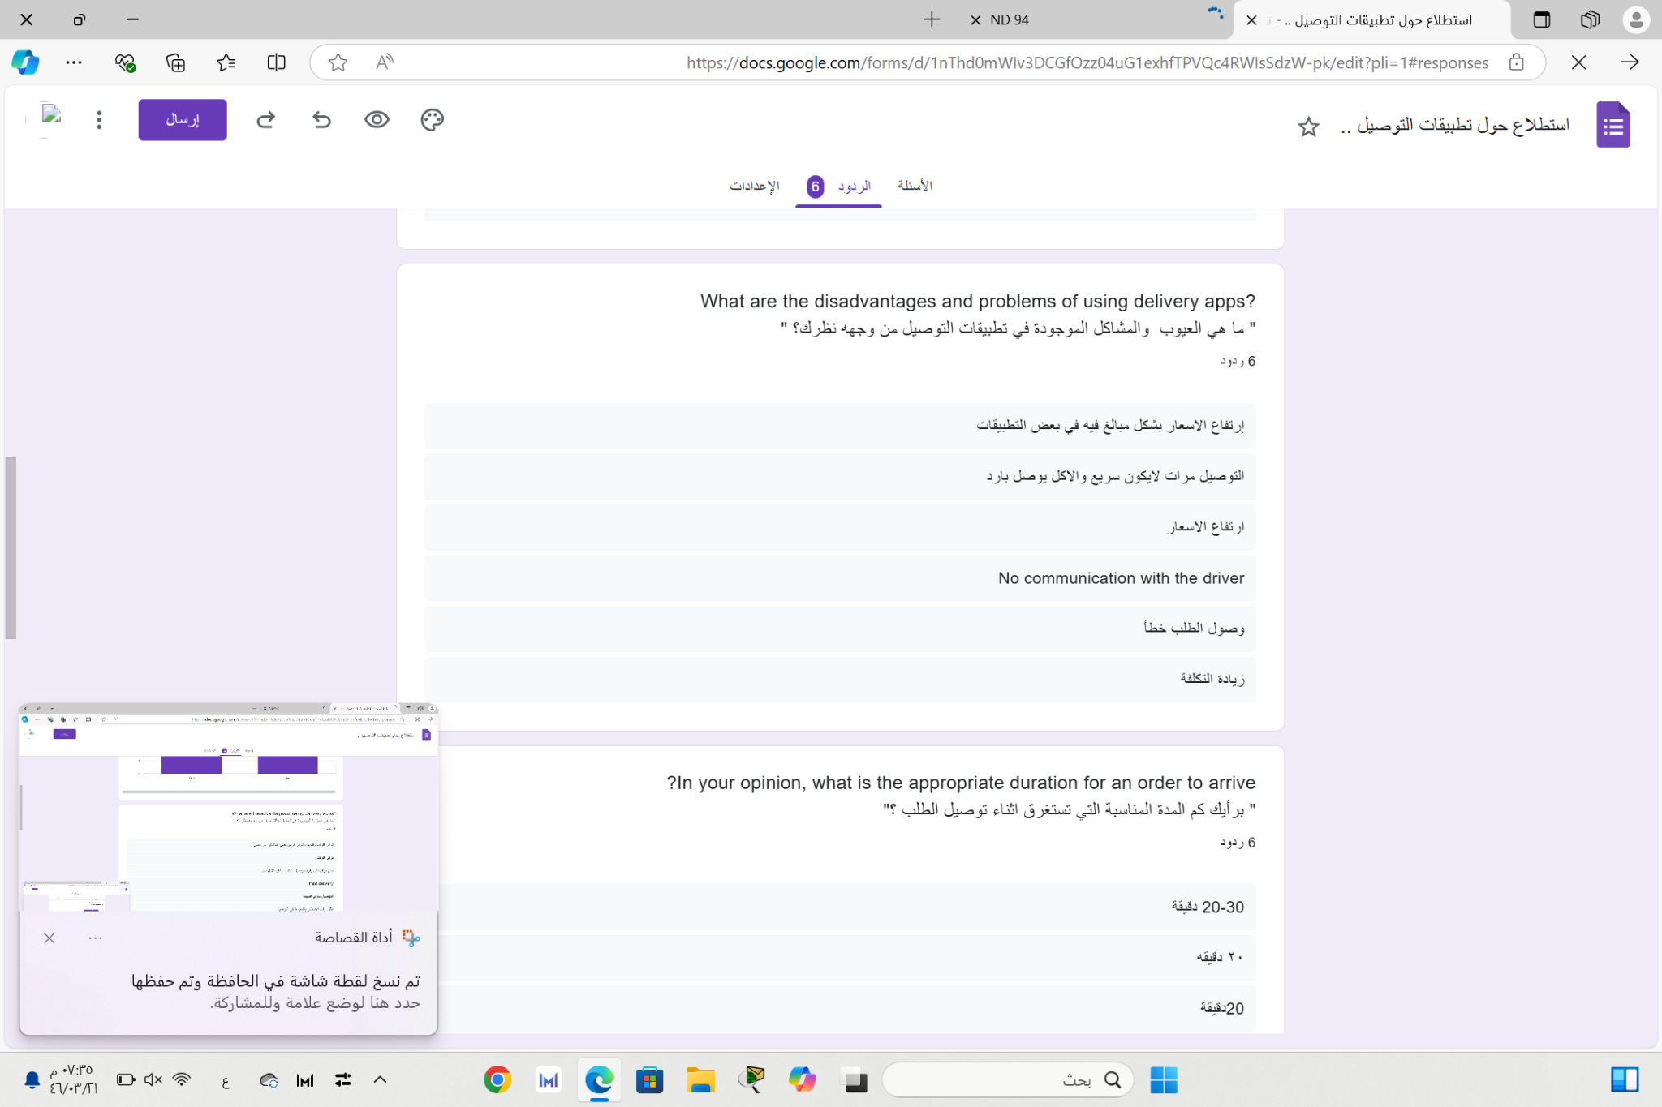

100% of those who answered this survey indicated that they use delivery apps.

They mentioned advantages such as time and effort savings, additional job opportunities, order tracking, multiple payment methods like Apple Pay, delivery to remote areas, reduced waiting time, and fast delivery.

Disadvantages included excessively high prices, occasional delays in delivery, receiving cold or poor-quality food, and increased costs. Supporters believed these apps deserve more popularity than those who oppose the idea.

The ideal delivery time was suggested to be 30 minutes or a minimum of 20 minutes.

Suggestions for improvements included setting delivery prices suitable for the community, enhancing delivery quality, using food containers for intact and quality food delivery, displaying user reviews, delivering orders within 30 minutes maximum, choosing suitable delivery times for individuals, and integrating all stores and locations into one app.

Respondents believed these apps had a significant positive impact on society during the COVID-19 pandemic by saving time and reducing congestion.

**Similar Applications:**

There are similar applications to the one we discussed, such as

Jahez, HungerStation, and Mrsool.

Their advantages include:

efficient delivery service, return and exchange feature for order errors, widespread availability with good ratings on the App Store.

However, they lack abundant discount coupons or codes, do not cover all restaurants, and have high delivery fees especially for rural and remote areas compared to our app which offers multiple payment methods including Tabby and Tamara, a free one-month delivery subscription, discount coupons, free delivery for large orders, special discounts for new users, and free delivery on the.